Abandoned Attacked | Abused | Betrayed | Blamed | Bullied | Cheated
Coerced Criticized | Dismissed | Disrespected | Excluded | Ignored | Intimidated
Insulted Let Down | Manipulated | Misunderstood | Neglected | Put down | Rejected
Unappreciated Unloved | Unheard | Unwanted | Used | Violated | Wronged
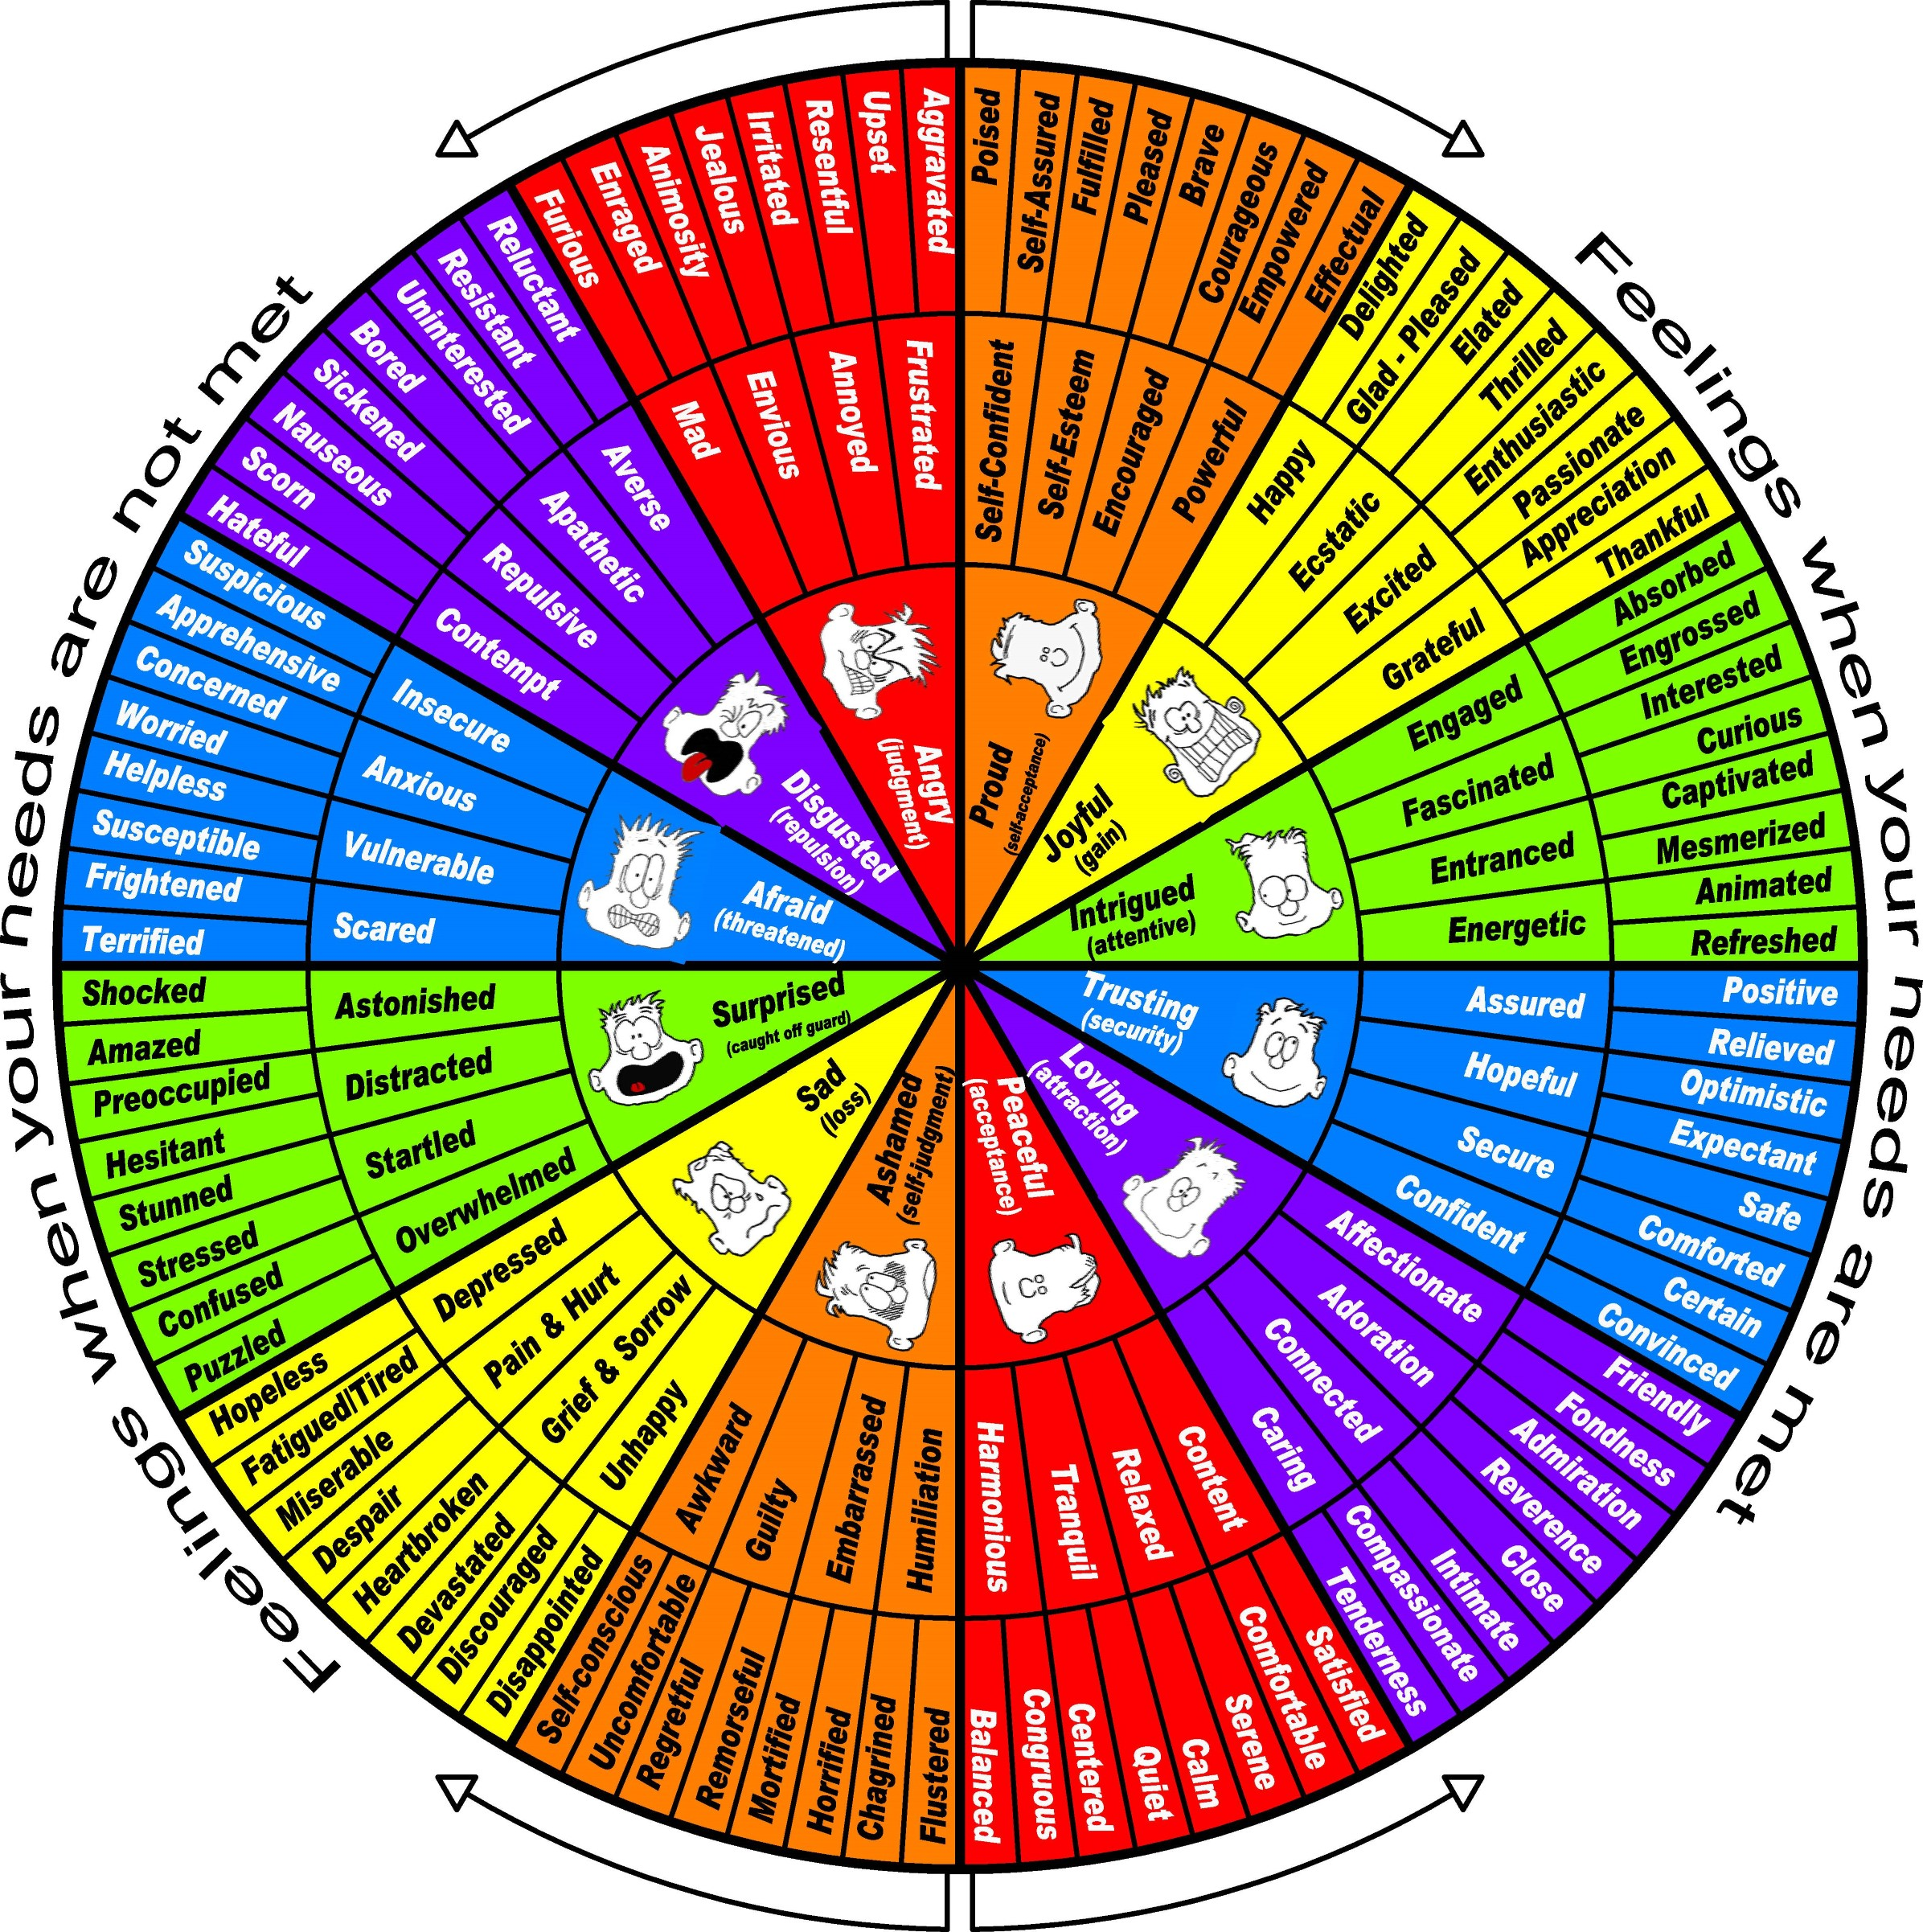Feelings Wheel
Feelings are internal emotions. Words mistaken for emotions (see list above the wheel), but that are actually thoughts in the form of evaluations and judgments of others, are any words that follow feel likeor "I feel that - or "I feel as if " or “I feel you_______.”
Based on Nonviolent Communication by Marshall Rosenbera, Ph.D. May be duplicated for personal use and for teaching Nonviolent Communication.

Universal
Interdependent Needs
To receive, as well as to extend to others.
acceptance—inclusion—appreciation
(confirmation that a positive contribution has been made)
compassion
(caring response to a perceived pain)
Connection, consideration
(of our and others’ needs or preferences)
Cooperation, community
(being part of something larger than ourselves)
Empathy, honesty
(honest feedback on our words and behaviors that enables us to learn from past behaviors and limitations)
warmth, closeness, intimacy, respect,
self-respect, support, nurturance
trust, reassurance, understanding
(to understand and be understood)
visibility(to see and be seen or noticed
Rest and play
Enjoyment, challenge, stimulation, ease,
Needs
Safety and Health
security
dependability, consistency
Harmony and balance
beauty, order, peace
wholeness, equality, mutuality
inspiration, communion
Autonomy and Authenticity
Autonomy (to choose one’s goals, values, dreams, And ways to realize them)
Integrity (to live one’s values)
Authenticity (to be true to oneself)
Clarity and Awareness
Consciousness, understanding
(the need for knowledge, wisdom, experience)
Purpose and Effectiveness
Contribution (to the enrichment of life)
Meaning, purposeful activity, work
Growth, competence, creativity,
self-expression

Relaxation, Celebration, And mourning
(of life and the cycles of birth, death

Four Pillars of Emotional Intelligence
And Exercises to Apply in Real Life

- Self Awareness: ARSOB Worksheet.
- Self Management: New SOB Worksheet.
- Social Awareness: Empathy Buddy Exercise.
- Relationship Management: MBTI Assignment.
Then, Supervisory Language, Customer Service and Personal Selling, Coaching, Group Facilitation, and Mediation are processes that fit naturally with these skill sets.
There are 3 homework reflection assignments that enhance skills in these areas.

Assignment #1 Emotional Resilience Worksheet Explanation
The following four steps are deconstructing automatic, habitual, reactive States Of Being. Write down the following:
- Situation—Name it.
- Automatic Reactive State Of Being (ARSOB)—Name it (see list).
- Stimulus that activated the ARSOB—Name it.
- Thoughts and Emotions that support/promote the ARSOB—articulate them.

You have now named and de-constructed the details of this Automatic Reactive State Of Being. This enables you to choose to get out of the Flight/Fight/Freeze part of the brain and refocus from your pre-frontal cortex. Now, you can set aside the Automatic Reactive State Of Being (if you don’t use it, you lose it, neurally speaking) and write down:
- Choose a New State Of Being (see page 4)), what is it?
- Choose New Thoughts and Emotions that support/promote your New State Of Being; what are they?
- Pay lots of attention to the New Thoughts and Emotions and New S.O.B. to accelerate wiring in new neural networks: “whatever fires together, wires together.” Refresh every time you know you will face the Situation.
- Repetition Is The Mother Of Skill.
Watch these videos on brain science and emotional contagion:
https://www.youtube.com/watch?v=8l2nvTv9_Xw
https://www.youtube.com/watch?v=apzXGEbZht0&t=14s
https://www.youtube.com/watch?v=e3xgh-5lxlQ&t=73s

Assignment #1 Emotional Resilience Worksheet
“Maintaining Composure in Challenging Situations”
Situation: Brief and as simple as possible.
Automatic Reactive State of Being (ARSOB). 1-3 words, see vocabulary.
Stimulus: What did you see or hear (external) or think (internal) that caused that ARSOB?
Thoughts (phrases or sentences) and Emotions (words) that support the ARSOB.
Thoughts produce a chemical that generate an Emotion that produces a Thought that produces a chemical that produces an Emotion that produces……
Thought: |  |  |  | Emotion:
Thought: |  |  |  | Emotion:
Thought: |  |  |  | Emotion:
Thought: |  |  |  | Emotion:
Thought: |  |  |  | Emotion:
Now that I have CLARITY, I can CHOOSE to set aside the ARSOB (you don’t use it you lose it), and CREATE a New SOB (whatever fires together wires together).
New SOB and this is the same Situation and the Same Stimulus, but I’m creating a New SOB.
Thought: |  |  |  | Emotion:
Thought: |  |  |  | Emotion:
Thought |  |  |  | Emotion
Thought |  |  |  | Emotion

Now go out and experience the New SOB!

Example of Assignment #1Emotional Resilience Worksheet
“Maintaining Composure in Challenging Situations”
Situation: Brief and as simple as possible. | Looking at today’s work schedule.
Automatic Reactive State of Being (ARSOB). 1-3 words, see vocabulary. |  |  | Overwhelmed.
Stimulus/Trigger: What did you see or hear (external) or think (internal) that activated that ARSOB? |  | Thoughts about workload.
Thoughts (phrases or sentences) and Emotions (words) that support the ARSOB.
Thoughts produce a chemical that generate an Emotion that produces a Thought that produces a chemical that produces an Emotion that produces……
Thought: “Oh, my god, I didn’t do ________” |  |  |  | Emotion: panic
Thought: “I’m not keeping up.” |  |  |  | Emotion: despair
Thought: I’m not enough>” |  |  |  | Emotion: defeated
Thought: “What’s wrong with me?” |  |  |  | Emotion: shame
Thought: “I’m letting people down.” |  |  |  | Emotion: guilt
Now that I have CLARITY, I can CHOOSE to set aside the ARSOB (you don’t use it you lose it), and CREATE a New SOB (whatever fires together wires together).
New SOB and this is the same Situation and the Same Stimulus, but I’m creating a New SOB.
Accepting, calm. Confident.
Thought: “I’m going to write it down.” |  |  |  | Emotion: relief
Thought: “I’m going to find a way to capture information” |  |  |  | Emotion: structured, stable
Thought: “It’s not the end of the world.” |  |  |  | Emotion: relief, accepting
Thought: “It’s going to work out.” |  |  |  | Emotion: soothing

Emotional Resilience Assignment # One Checklist and Debrief Tool

- Make sure all ingredients are filled in, especially the Thoughts And the Emotions.

- When coaching, be curious and continuously scanning for missing pieces or inaccuracies. Make certain you’re clear so they’re clear.

- Make sure they’re clear about Distinctions between thoughts and emotions.

- Coach people to get concise about Situation—ARSOB—Stimulus (generally story wants to take over).

- Uncover thoughts to find emotions or uncover emotions to find thoughts (thoughts are sentences and emotions are words) that support the ARSOB.

- Thoughts produce chemicals that produce emotions that produce more thoughts (*Vicious Cycle).

- Make sure coachee writes down all ingredients—for clarity.

- Stress the necessity of precision about emotions, especially, and thoughts, to maximize clarity which yields greater awareness which allows clearer access to choice.

- Reminder: we’re deconstructing the ARSOB into all its pieces for greater awareness which allows clearer access to choice.

- There’s a ripple effect into other situations where the same ARSOB used to live.

- You used to be owned and enslaved by the old ARSOB; the awareness gives you the power to unshackle your self.
- When the ARSOB owns you, the stimulus acts like a junkyard dog whose jaws snap shut around your ankle. When you get clarity about the old ARSOB, you have the ability to choose to not be attacked at all by the junkyard dog AKA stimulus, and thus not get gripped by the ARSOB. By the way, this is the moment (stimulus) when stress starts attacking your mitochondria, affecting your adrenal glands and damaging your immune system.

- The old ARSOB runs the rumination machine, living in the past or the future, creating chronic stress. Also, another thing you can stop worrying about is “wondering why” you’re thinking about something or ruminating over it.

- The worksheet is your brain map—of the old ARSOB and the New SOB. Without the worksheet, there’s a lot of room for unnecessary, inhibiting ambiguity.

- And, not only can your brain see in ink on paper what before had been a storm in your head and heart, specifically and distinctly what was going on, your hands have gobs of neurons linked directly to your brain. Don’t underestimate the value of the worksheet.

- When you walk away from our conversation, you will continue to uncover other thoughts and emotions you have had. And, you will also continue to think of new thoughts and emotions you can create to support the New SOB.

- You now have the clarity to set aside the ARSOB, to choose NOT to use it; you don’t use it, you lose it! (see Dr. Joe video about the synapses pruning away).

- NOW THAT YOU’RE REAL CLEAR ABOUT THE MAKEUP OF THE OLD ARSOB, YOU CAN SEE IT CLEARLY AND CHOOSE TO NOT USE IT—YOU DON’T USE IT YOU LOSE IT!
- Caution: if you don’t create a New SOB and new thoughts and emotions to support it, the old ARSOB is the default and will rise up and take over immediately.

- The reason for using a different color ink on the New SOB vs. the old is that the brain sees it as a visual difference.

- When working on the New SOB, don’t mix actions or techniques into that conversation/creation. Dismantling the ARSOB and not using it and creating the New SOB form a foundation from which intuitive-driven words and deeds can emerge.

- Invest in the process of working from the foundation, and let go of expectations, results or outcomes.

- When it comes to communication, your SOB is revealed through 55% physicality, 38% voice—93% of what you communicate. The 7% Words are the fruit of the 93%.

- Sustaining the New SOB is crucial. If you fall down, get back up and go again. Being restartable is being unstoppable. And, Repetition Is The Mother Of Skill.

- Whatever fires together, wires together—see Dr. Joe video. (*Virtual Cycle!)

- Quantum physics proves this as well; whatever you pay attention turns from energy into matter.

- Very quickly, this gets to be fun!

Empathy Buddy Exercise Guidelines
- Arrange a day and time to have the conversation.
- Refresh feelings and needs vocabulary.
- Determine how long you each have for speaking/listening.
- Establish confidentiality.
- Being present and making a connection are the intentions and practicing empathic guessing are the goals.
- Listener (empathic guesser) is to feedback ONLY what the speaker’s feelings and needs are without engaging in (see list below) during the conversation, if appropriate.
- Empathy is not: Sympathy Suggestions Advice Fixing Resolving Investigation (clarifying is okay) Diagnosing Analyzing Solving One-upping Educating Consoling Storytelling Interrogating Shutting Down Explaining Correcting

- Speaker is encouraged to tell an authentic, emotion-filled story, either positive, negative, or both.
- Listener summarizes for accuracy and clarity.

- Then, both Speaker and Listener debrief using sample debrief questions below.
- Speaker can allow for listener to offer solutions/suggestions after the empathic listening is over.
- Switch and repeat.

Here’s the beautiful part—if you’re not right, precise or accurate when you’re using these skills, people will correct you and put you on the right path! Practice and play

Sample Debrief Questions
As Speaker:
- Did this help make things clearer for you? If so, how?
- Were your emotions correctly identified? If so, how?
- Did the feedback, even if inaccurate, prompt you to have a different perspective or feel validated? In what way?
- What did you learn about yourself, or about Empathic Guessing?
As Listener (Empathic guesser)
- How did you do maintaining your S.O.B. during the exercise?
- What parts were difficult about this?
- What was easy, smooth, or natural?
- If you could go back and change or improve anything, what would it be?
- What did you learn about yourself, or about Empathic Guessing?

Empathic Guessing/Intuition Skills Sentence Stems
Empathy is following the other’s conversation by holding a sacred space for:
- Seeing the other’s perspective.
- Being non-judgmental.
- Recognizing their emotions.
- Connecting with their emotions.
Connection is the energy that exists between people when they feel seen, heard, and valued; when they can give and receive without judgment; and when they derive sustenance and strength from the relationship. (The above taken from Brene Brown’s The Gifts of Imperfection).
In our nation we place a high value on telling people, “What’s So.” We get a lot of education on how to speak and write about what’s right and wrong. Knowing infers greater status. Uncertainty, ambiguity, and not knowing infer a lesser status. Listening skills are not emphasized, let alone taught in our academic institutions. Instead, we have debate teams!
I have learned that listening is at least as powerful, if not more powerful, than speaking. Following are ways to authentically listen and ask questions from a curious state of being. Also, you can turn statements into questions. You can do that by simply using an upward inflection at the end of the sentence. And, following are some sentence stems to get a dialogue started; feel free to create your own. Be sure to refer to the Needs and Feelings Lists.
First of all, Being and Staying Relaxed, Calm, & Curious is an effective SOB to operate from; feel free to choose your own. And, the following sentence/question stems need to emerge from a deliberate S.O.B. Curiosity promotes listening to and acting from your intuition, instead of thinking of what to say.
Reflecting Emotion: the listener reflects back the speaker’s Emotions and Feelings:
- My sense is______________. (?)
- I’m hearing______________. (?)
- Sounds like______________. (?)
- You are feeling____________. Are you feeling___________?
- You are concerned about___________. Are you concerned about______________?
See Front Page for Some Emotions and Feelings Vocabulary When Needs Are Not Met

Accessing Real Needs: the listener explores the need (the feeling is the scent, the need is the flower) underlying a position or stance.
- Do you need to feel______________?
- Are you wanting_________________?
- Sounds like you value_____________. (?)
- _______________is important to you. (?)
- You would like ____________. Would you like________________?

Unmet needs underlie why a person takes a position on an issue—usually Intangible, invisible, and emotional. See page 2 for list.

